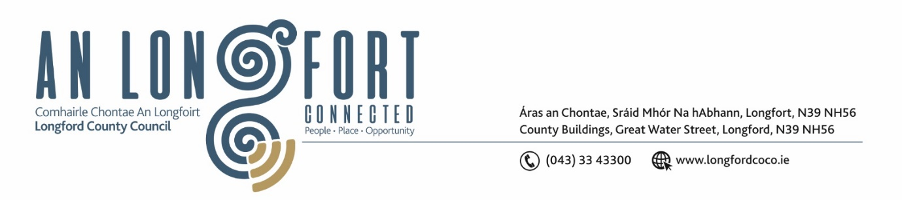

***Please note meeting will be held in the Council Chamber and via Microsoft Teams.***

7 April 2022.

**Chuig: Gach Ball don Chomhairle.**

A Chomhairleoir,

Iarrtar ort bheith i láthair ag Cruinniú Míosuil Chomhairle Chontae Longfoirt a tionólfar i Seomra na Comhairle, Aras an Chontae, Longford agus via MS Teams are an **Chéadaoin 13ú Aibreáin 2022 ag** **3pm** chun gnó a dhéanamh d’réir an Chláir thíos.

You are requested to attend the Monthly Meeting of Longford County Council to be held in the Council Chamber and **via Microsoft Teams** on **Wednesday 13 April 2022 at 3pm** to transact business, as set out on the agenda hereunder.

Mise le meas,

*Ann Marie Mc Keon*

**__________________**

**Ann Marie Mc Keon**

**Meetings Administrator.**

**C L Á R**

Prayer before meeting.

**1.** Confirmation of Minutes:

(i) Monthly Meeting of Longford County Council held on 9 March 2022– copy enclosed.

(ii) Committee Meeting of Longford County Council held on 9 March 2022 –

copy enclosed.

**2.** Matters Arising.

**3.** Declaration of Interest by Members.

**4.** To note Management Report – enclosed.

**5.** To note adopted Minutes of Corporate Policy Group Meeting held on the

8 February 2022 – enclosed.

**6. Community, Corporate and Enterprise**

**(a)** Consideration of Draft Annual Report 2021 prepared in accordance with section

221 of the Local Government Action 2001 as amended – enclosed.

**(b)** Consideration of amendments to Draft Civic Protocols December 2016 – enclosed

**(c)** Consideration ofestablishment of Protocols and Procedure Committee and nominations to this committee.

**(d)** Modernisation of the Electoral Registration Process Update.

**7.** **Planning and Project Delivery**

**(a)** To note Planning Applications received since last meeting of the Council.

**(b)** Consideration of the disposal of a strip of land at Townspark, Longford in accordance with the terms of Section 183 of the Local Government Act 2001 issued on the 29 March 2022.

**(c)** Notice of Motions, submitted by Councillors, as listed hereunder –

**Councillor Uruemu Adejinmi**

**“**I call on Longford County Council to introduce a self-help scheme for tenants of Longford County Council houses. Such a scheme will enable Council tenants carry out repairs/replacement works in their council house once their application is approved”.

**8. General**

Notice of Motions, submitted by Councillors, as listed hereunder –

**Councillor Martin Monaghan**

“I am calling on Longford County Council to engage and work with the other stakeholder namely LWETB on the Connolly Barracks site to work in delivering a state-of-the-art apprenticeship centre in the heart of Ireland”.

**Councillor Paraic Brady**

“I call on the Minister for Justice, Helen McEntee to carry out an immediate review of the Free Legal Aid System”.

**9. Training**

**10. Votes of Sympathy**